

Central & Local Benefits Issue

Summary of the Issue
During the 2023-2025 bargaining round, Local 5441 negotiated a Letter of Understanding (LOU) with the Employer to remain in our existing benefits plan, outside of the Central CUPE/OCHU benefits plan.
At that time, our benefits plan was superior to the Central plan.
In the 2025 to 2028 Central negotiations, CUPE/OCHU improved the Central benefits plan and now we (Clerical and Service bargaining units) must decide whether to stay with our local benefits or join Central benefits.
If we choose to move to Central, the Employer has indicated the following changes (but we would fight back!):
- Loss of 4 service providers (because they are not specifically mentioned in Central benefits):
  - Audiologist
  - Nutritionist
  - Occupational Therapist
  - Acupuncture
- Dental premiums increase by 3.3%
- Extended Health Care premiums decrease by 0.8%
Both Clerical and Service bargaining units must make the same decision, as per the LOU. One bargaining unit cannot decide to join central and the other chooses to stay local.

Upcoming Changes to Local Benefits
If members in the Clerical and Service bargaining units choose to remain with local benefits, here are the changes the Employer has advised will be taking place effective April 1, 2026:

HEALTH & DENTAL BENEFITS
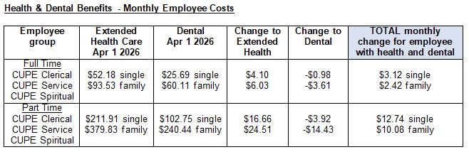

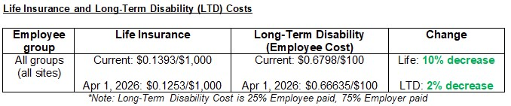
LIFE INSURANCE AND LTD BENEFITS
QUICK RECAP OF THE ISSUE IN QUESTION
SERVICE PROVIDERS IN DISPUTE:
- Audiologist
- Nutritionist
- Occupational Therapist
- Acupuncture
CHANGES IN PREMIUMS FOR LOCAL BENEFITS:
- Dental premiums increase by 3.3%
- Extended Health Care premiums decrease by 0.8%

HOW TO FIGHT BACK (IF WE CHOOSE TO JOIN CENTRAL)
Should the OHA continue to take the position that affected members are no longer eligible to the four service providers, there are several options available to the Local to fight it:
- Bargaining
- Implementation Dispute
- Grievance Process

L5441.00/.01 Benefits Information Session scheduled for Tuesday, March 24th @ 4pm (Zoom)

